MINI MARKET MANAGEMENT SYSTEM

Abstract
The Mini Market Management System is a desktop application developed using C# and SQL Server to manage products, categories, sellers and billing.

Table of Contents
1 Introduction
2 Objectives
3 Requirement Analysis
4 Methodology
5 System Design
6 Database Design
7 ER Diagram
8 Implementation & Screenshots
9 Testing
10 Conclusion
11 Future Scope
12 References

1 Introduction
This project automates mini market management including billing, product inventory, seller management and category management.

2 Objectives
• Reduce manual work
• Improve accuracy
• Manage inventory
• Generate bills automatically

3 Requirement Analysis
Functional requirements include CRUD operations and login validation. Non-functional requirements include reliability, usability and security.

4 Methodology
The project was developed using modular design and integrated with SQL Server database.

5 System Design
The system consists of Login, Seller, Product, Category and Billing modules connected to database.

6 Database Design
The project database consists of AdminTbl, SellerTbl, CategoryTbl, ProductTbl and BillTbl.

9 Testing
Tested for login, CRUD operations, billing and SQL connectivity.

10 Conclusion
The system automates mini market operations efficiently.

11 Future Scope
Barcode, cloud integration and analytics can be added.

12 References
Microsoft Docs
SQL Server Docs
Visual Studio

Detailed Database Schema

AdminTbl
AdminId (PK)
AdminName
AdminPassword

SellerTbl
SellerId (PK)
SellerName
SellerAge
SellerPhone
SellerPassword

CategoryTbl
CatId (PK)
CatName
CatDescription

ProductTbl
ProdId (PK)
ProdName
ProdQty
ProdPrice
ProdCategory

BillTbl
BillId (PK)
SellerName
TotalAmount
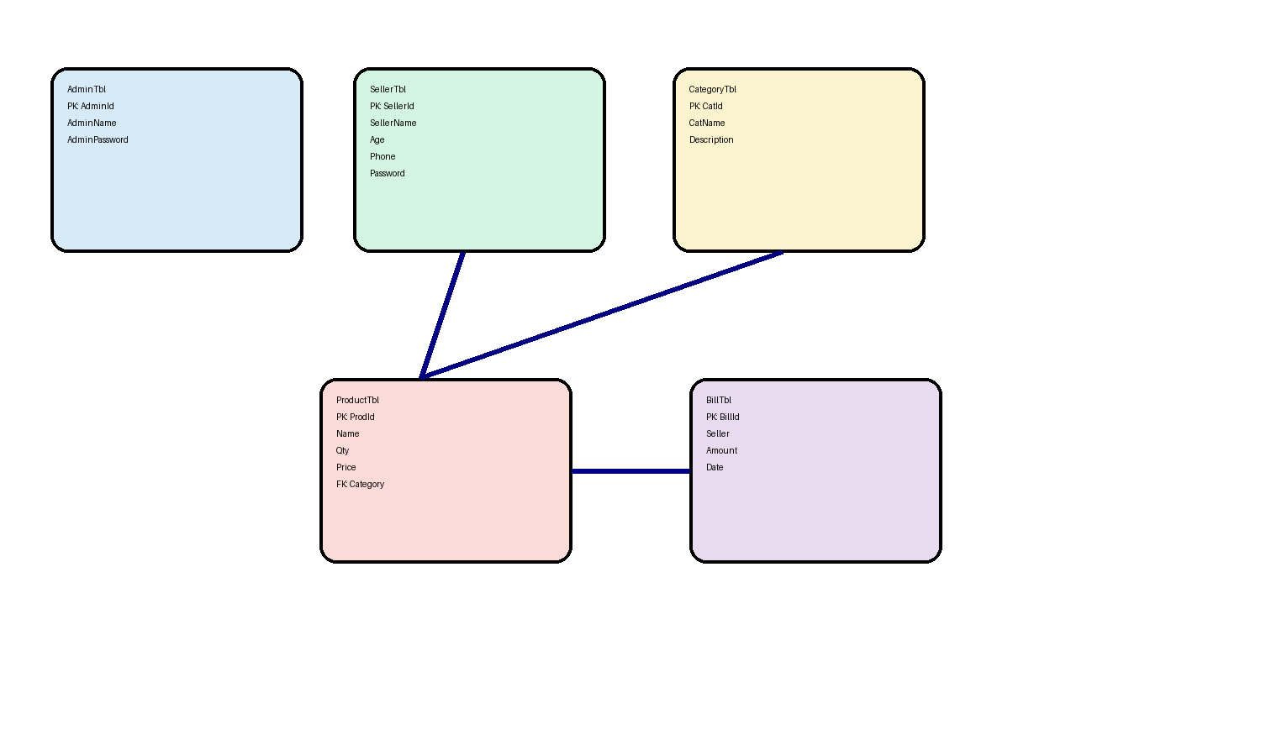
BillDate

Professional ER Diagram

